Experiment 07

Aim:
Implementation of Operator Precedence Parser

Theory:
An operator precedence grammar is a kind of grammar for formal languages.
Technically, an operator precedence grammar is a context-free grammar that has the property (among others)[ that no production has either an empty right-hand side or two adjacent nonterminals in its right-hand side. These properties allow precedence relations to be defined between the terminals of the grammar. A parser that exploits these relations is considerably simpler than more general-purpose parsers, such as LALR parsers. Operator-precedence parsers can be constructed for a large class of context-free grammars.
A grammar that is used to define mathematical operators is called an operator grammar or operator precedence grammar. Such grammars have the restriction that no production has either an empty right-hand side (null productions) or two adjacent non-terminals in its right-hand side. Examples – This is an example of operator grammar:
E->E+E/E*E/id
However, the grammar given below is not an operator grammar because two non-terminals are adjacent to each other:
S->SAS/a
A->bSb/b

Operator precedence parser – An operator precedence parser is a bottom-up parser that interprets an operator grammar. This parser is only used for operator grammars. Ambiguous grammars are not allowed in any parser except operator precedence parser. There are two methods for determining what precedence relations should hold between a pair of terminals:
- Use the conventional associativity and precedence of operators.
- The second method of selecting operator-precedence relations is first to construct an unambiguous grammar for the language, a grammar that reflects the correct associativity and precedence in its parse trees.
This parser relies on the following three precedence relations: ⋖, ≐, ⋗ a ⋖ b This means a “yields precedence to” b. a ⋗ b This means a “takes precedence over” b. a ≐ b This means a “has same precedence as” b.
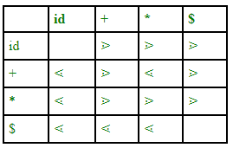
Figure – Operator precedence relation table for grammar E->E+E/E*E/id
There is not any relation between id and id as id will not be compared and two variables can not come side by side. There is also a disadvantage of this table – if we have n operators then size of table will be n*n and complexity will be 0(n^2). In order to decrease the size of the table, we use the operator function table. Operator precedence parsers usually do not store the precedence table with the relations; rather they are implemented in a special way. Operator precedence parsers use precedence functions that map terminal symbols to integers, and the precedence relations between the symbols are implemented by numerical comparison. The parsing table can be encoded by two precedence functions f and g that map terminal symbols to integers. We select f and g such that:
- f(a) < g(b) whenever a yields precedence to b
- f(a) = g(b) whenever a and b have the same precedence
- f(a) > g(b) whenever a takes precedence over b

Example
Grammar:
- E → E+T/T
- T → T*F/F
- F → id
Given string:
- w = id + id * id
Let us consider a parse tree for it as follows:
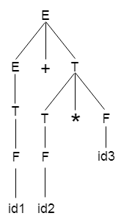
On the basis of above tree, we can design following operator precedence table:
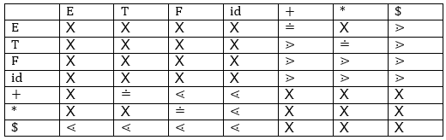
Now let us process the string with the help of the above precedence table:
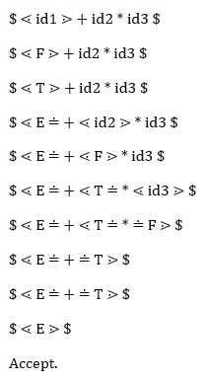

Code:
import numpy as np
from tabulate import tabulate

def getOperators(grammar):
operators = []
operators.append("#")
for key in grammar:
for production in grammar[key]:
for char in production:
if char in "+-*/&|!^%@()":
operators.append(char)
for key in grammar:
for production in grammar[key]:
if production.islower():
operators.append(production)
return operators

def getPrecedence(operators):
precedence = {}
for i, operator in enumerate(operators):
precedence[operator] = i
return precedence

def PrecedenceTable(precedence):
table = []
headers = [""] + list(precedence.keys())
table.append(headers)
for key in precedence:
row = [key]
for key2 in precedence:
if precedence[key] > precedence[key2]:
row.append(">")
elif precedence[key] < precedence[key2]:
row.append("<")
else:
if precedence[key] == 0:
row.append("A")
elif precedence[key] == len(precedence) - 1:
row.append("=")
else:
row.append(">")
table.append(row)
return table

def checkString(string, grammar, precedence):
table = []
stack = []
stack.append("#")
stack.append(string[0])
headers = ["stack", "input", "action"]
table.append(headers)
string = list(string)
string.append("#")
string.reverse()
while len(string) > 0:
stack_str = ""
for i in stack:
stack_str += i
input_str = ""
for i in string:
input_str += i
if stack[-1] in precedence and string[-1] in precedence:
if precedence[stack[-1]] < precedence[string[-1]]:
stack.append(string.pop())
action = "Shift"
elif precedence[stack[-1]] > precedence[string[-1]]:
stack.pop()
action = "Reduce"
else:
stack.pop()
string.pop()
action = "Reduce"
else:
stack.append(string.pop())
action = "Shift"
table.append([stack_str, input_str, action])
if len(stack) == 0 and len(string) == 0:
table.append(["-", "-", "String Accepted"])
else:
table.append(["-", "-", "String Rejected"])
return table

def main():
print("To input epsilon enter #")
no_of_productions = int(input("Enter the no of productions: "))
grammar = {}
for _ in range(no_of_productions):
non_terminal = input("Enter Non terminal: ")
production = input(f"Enter production of {non_terminal}: ")
grammar[non_terminal] = production.split("|")
grammar[non_terminal] = [production.replace(" ", "") for production in grammar[non_terminal]]
print("\nThis is the input grammar:")
for g in grammar:
print(g, '->', grammar[g])
operators = getOperators(grammar)
precedence = getPrecedence(operators)
print("Operators:", operators)
print("Precedence: ", precedence)
table = PrecedenceTable(precedence)
print(tabulate(table, headers="firstrow", tablefmt="grid"))
string = input("Enter the string to check: ")
table = checkString(string, grammar, precedence)
print(tabulate(table, headers="firstrow", tablefmt="grid"))

if __name__ == "__main__":
main()

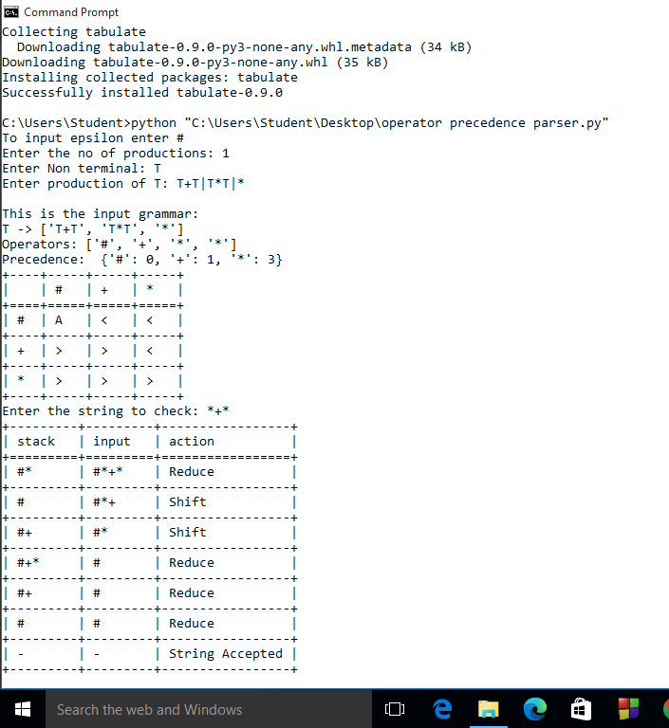
Conclusion:
In conclusion, the implementation of an Operator Precedence Parser presents a robust solution for parsing mathematical expressions efficiently. By leveraging a set of rules defining operator precedence and associativity, this parser effectively interprets complex expressions without the need for explicit parenthesis. Through the meticulous design and implementation of algorithms, such as the Shunting Yard Algorithm or recursive descent parsing, this parser navigates through the input expression, evaluating operators in the correct order while adhering to precedence rules. Additionally, by utilizing data structures like stacks to manage operators and operands, the parser ensures optimal memory management and performance. The Operator Precedence Parser's versatility extends beyond arithmetic expressions to encompass a wide range of grammars, making it a valuable tool in compiler construction and parsing applications. Overall, its efficiency, simplicity, and adaptability underscore its significance in modern computational tasks.

